**LAPORAN PRAKTIKUM**

**ALGORITMA DAN PEMROGRAMAN**

**Pertemuan Ke-5**



**Disusun Oleh :**

|  |  |
| --- | --- |
| **NAMA** | **: NANANG SETYAWAN** |
| **NIM** | **: 185410025** |
| **JURUSAN** | **: Teknik Informatika** |
| **JENJANG** | **: S1** |

**STMIK AKAKOM**

**YOGYAKARTA**

**2018**

LAPORAN PRAKTIKUM

ALGORITMA DAN PEMROGRAMAN

PERTEMUAN KE-5

PRAKTIK 1

1. Boolean variable

public class LatihanVariabelBoolean1{

public static void main(String[]args){

boolean passed, largeVenue, grade;

passed= true;

largeVenue= false;

grade= passed;

System.out.println(passed);

System.out.println(largeVenue);

System.out.println(grade);

}

}

Output:

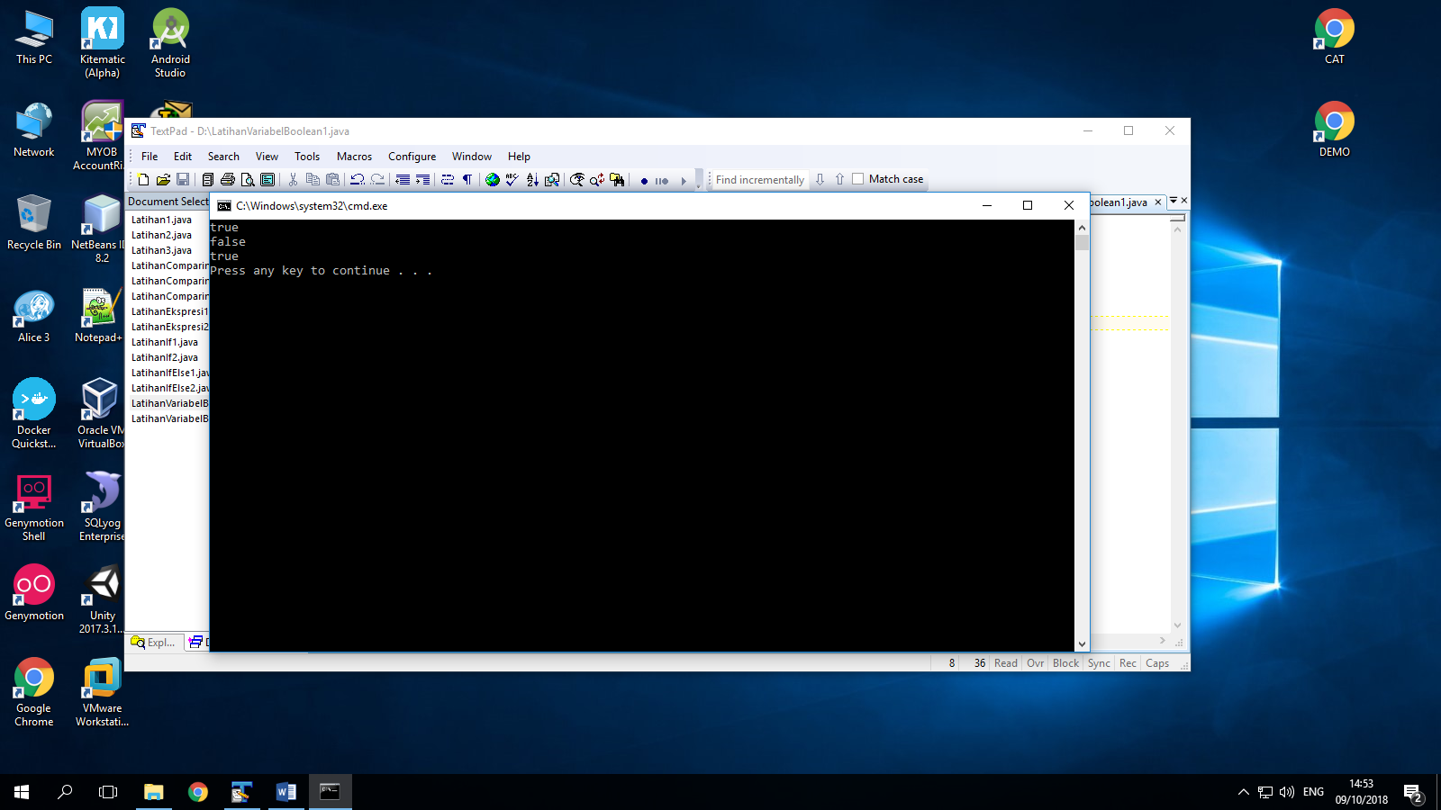

Explanation :

In this code we use Boolean data type because we will define true and false.

At the code above namely latihanvariabelboolean . we can match the code and output. In the first system.ou.println in code define passed. Look at the passed variable, its value is true. That’s why the first line at output is true.

Second system.out.println is largeVenue. Lets look at the largeVenue variable, its has false value. So that’s why second line in output is false.

Third system.out.println is grade. Lets see the code above. Grade variable has true value, that’s why the output in third line is true.

1. Boolean data type scenario

public class LatihanVariabelBoolean2{

public static void main(String[]args){

String left= "museum";

String straight= "gym";

String right= "restaurant";

boolean isLeft= false;

boolean isStraight= true;

boolean isRight= false;

System.out.println("Go straight ahead");

}

}

Output :

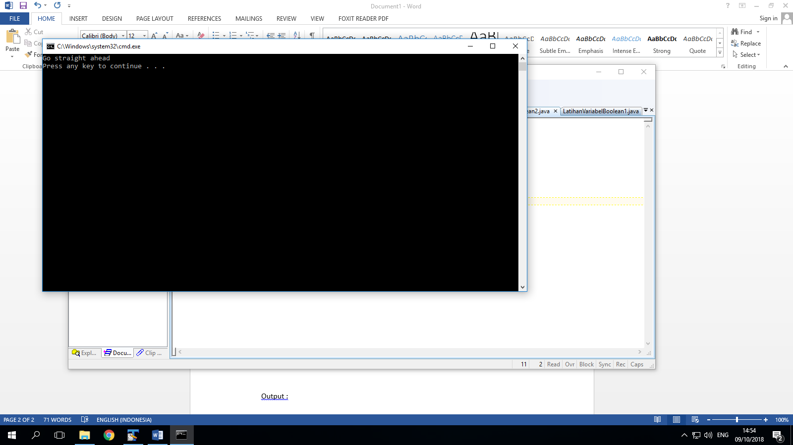

Explanation :

In this code there are many variable that’s has its value.

String left has “museum” value, String straight has “gym” value, and String right has “restaurant” value. Lets look at next code. Thera are Boolean, variable and its value. Left and right has false value, so straight must be true. That’s why the output is go straight away.

PRAKTIK 2

1. Comparison and task

public class LatihanEkspresi1{

public static void main(String[]args){

int x= 4;

System.out.println(x==5);

boolean isFive= x==5;

System.out.println(isFive);

}

}

Output :

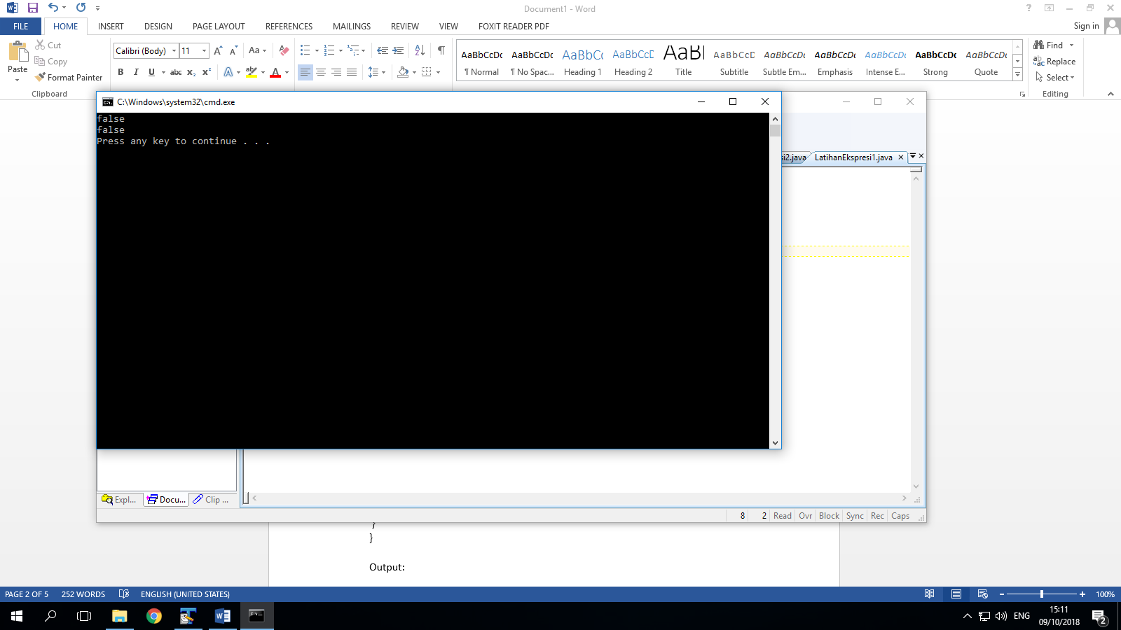

Explanation :

In this code we still use Boolean data type.

In code above there is int data type with the variable that’s int x=4

The system.out.println declarate that x==5, so we know its false because x==4, that’s why the output in the first line is false.

Then the variable isFive= x==5, it will also false because value of isFive is 4==5, same with condition before. That’s why the output in second line was false.

1. Boolean expression

public class LatihanEkspresi2{

public static void main(String[]args){

boolean res1= 24 ==15;

System.out.println("res1: "+res1);

int value1= 15;

int value2= 24;

boolean res2= value1 == value2;

System.out.println("res2:" +res2);

}

}

Output:

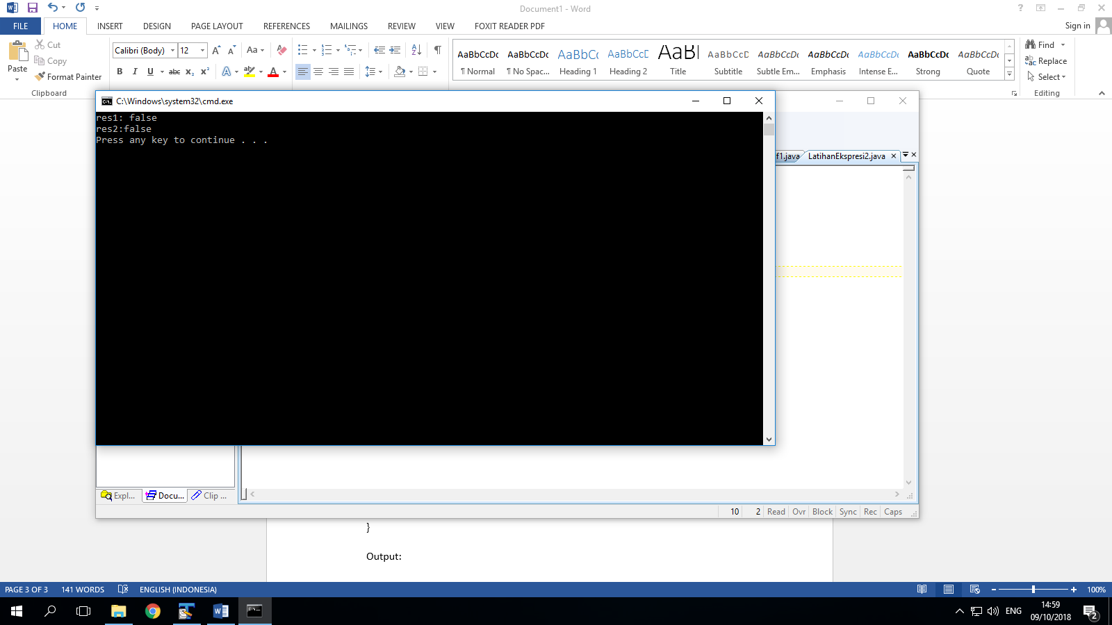

Explanation :

In this code we will use number comparison of Boolean expression.

Res1 is the variable and 24==15 is its value. So the system.out.println asked, is res1 ture or false if 24==15? And we know res1 is false because 24!=15, so the output in the first line is false.

The second line is same way but use different code. In this case it axplain that value1 is 15 and value2 is 24 then res2= value1==value2 then must be 15==24, but its false. Tahts why second output also false.

1. Relation operator

public class OperatorRelasi{

public static void main(String[]args){

int a=10;

int b=20;

System.out.println(a==b);

System.out.println(a!=b);

System.out.println(a>b);

System.out.println(a<b);

System.out.println(a>=b);

System.out.println(a<=b);

}

}

Output:

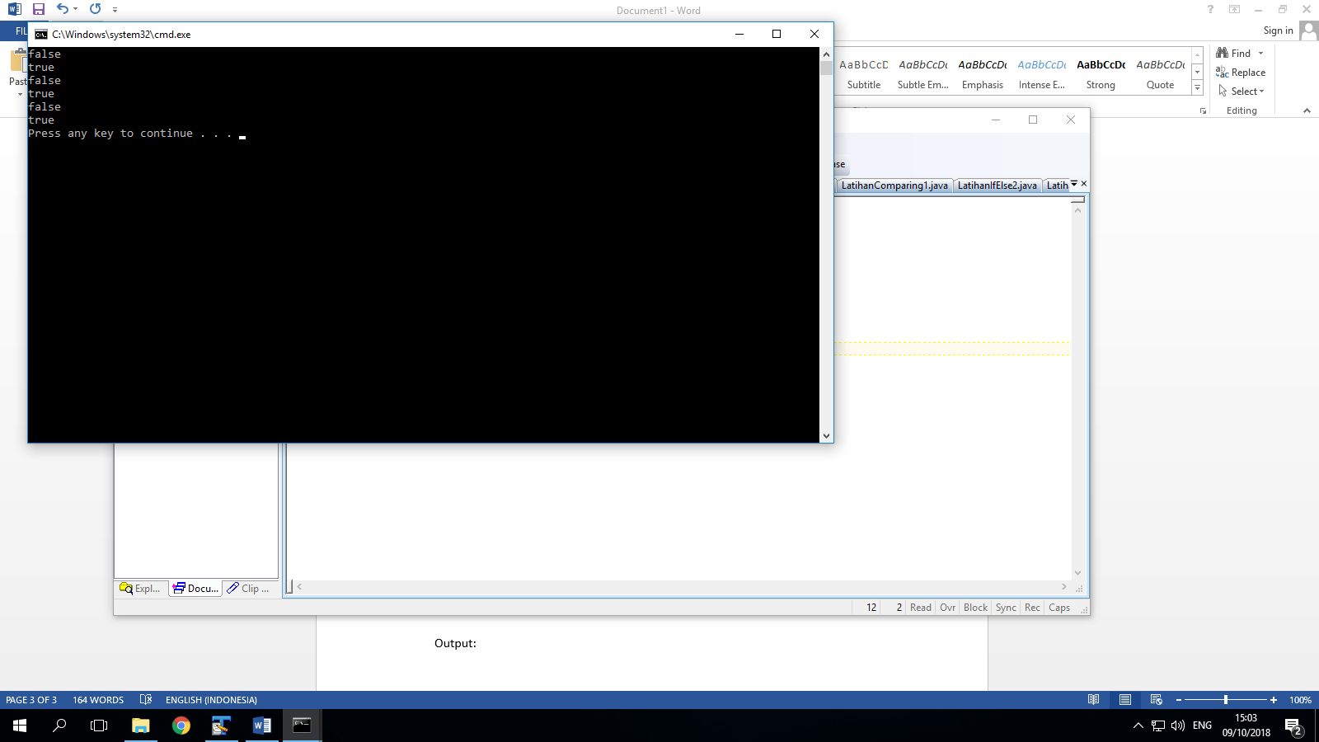

Expalantion :

In this code we use relation operator to compare to variable or value.

We can see a=10 and b=20.

1st output show false because its describe that 10 is same with 20.

2nd output show true because its describe that 10 not same with 20.

3rd output show false because its describe that 10 is bigger than 20.

4th output show true because its describe that 10 is smaller than 20.

5th output show false because its describe that 10 is bigger or same with 20.

6th output show true because its describe that 10 is smaller or same with 20.

PRAKTIK 3

1. LatihanIf1

public class LatihanIf1{

public static void main(String[]args){

String left= "museum";

String straight= "gym";

String right= "restaurant";

if(left=="gym"){

System.out.println("Turn Left");

}

if(straight=="gym"){

System.out.println("Drive Straight");

}

if(right=="gym"){

System.out.println("Turn Right");

}

}

}

Output:

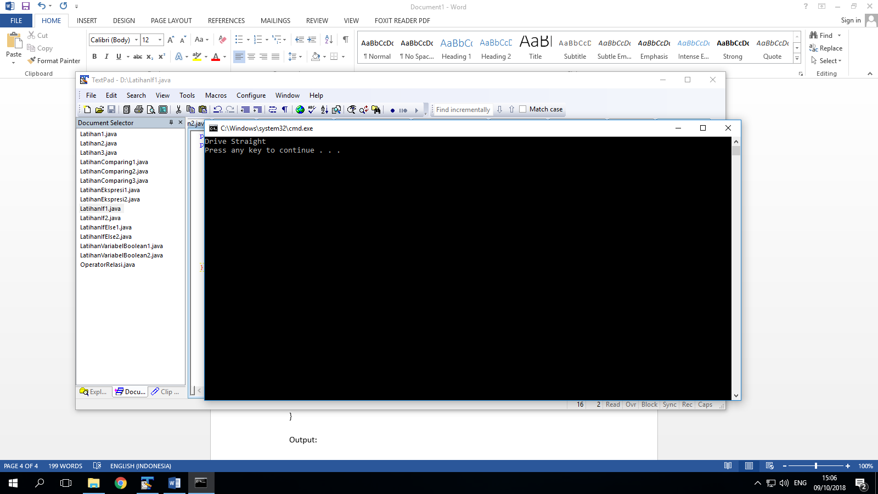

Explanation :

In this code we has 3 variable.

Left is museum, straight is gym, and right is restaurant.

In this case the program want go to gym. So we make 3 condition

1st if the gym in the left, so turn left.

2nd if the gym in straight, then drive straight

3rd if the gym in right, so turn right.

At the gym value its have straight variable, so straight = “gym”.

2nd condition is correct, that’s why we must drive straight if we want go to gym.

1. LatihanIf2

public class LatihanIf2{

public static void main(String[]args){

int grade= 85;

if (grade>88){

System.out.println("You made the Honor Roll");

}

if(grade<=88){

System.out.println("You are eligible for tutorial");

}

}

}

Output:

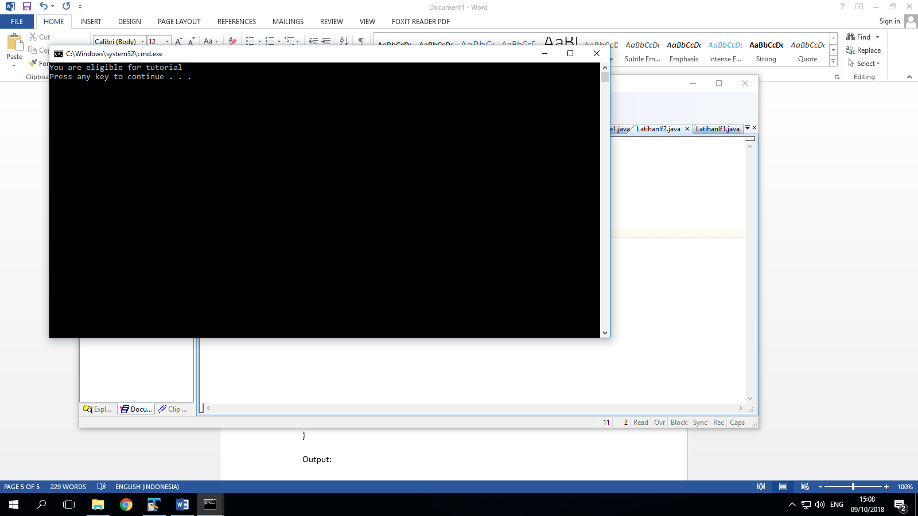

Explanation :

In this code we use two condition.

Look at the variable above, int grade= 85. So

1st if grade is bigger than 88 the output “you made the honor roll”

2nd if grade is same or smaller then 88 the output “you are eligible for tutorial”

And we can see grade is 85, so the correct is 85<88. Second condition fulfill this condition. So the output is you are eligible for tutorial.

PRAKTEK 4

1. If else stateman

public class LatihanIfElse1{

public static void main(String[]args){

String forecast;

double temperature= getTemperature();

if(temperature<=32.0){

forecast= "SNOW";

}

else{

forecast= "RAIN";

}

System.out.println(forecast);

}

public static double getTemperature(){

return 30.0;

}

}

Output :

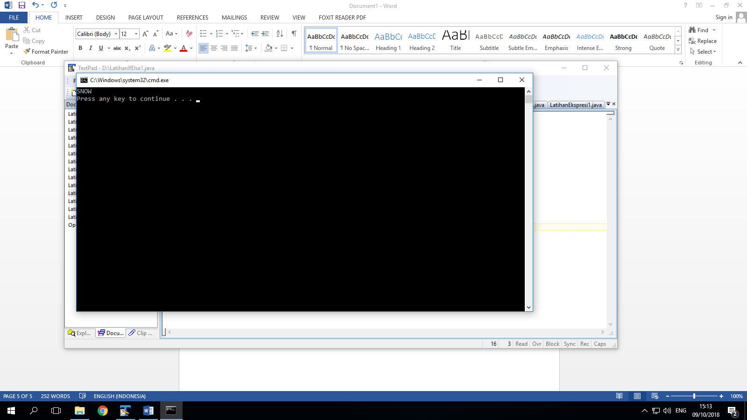

Explanation :

In this code we will see the temperature with if else statement.

Condition is

1st if temperature is smaller then 32.0, forecast weather is “SNOW”

2nd if temperature is bigger than 32.0, forecast weather is “RAIN”

And the temperature is 30.0. so the correct answer is temperature smaller than 32.0 then the second statement fulfil this condition.

1. If/else statement

public class LatihanIfElse2{

public static void main(String[]args){

int grade= 85;

if(grade>88){

System.out.println("You made the Honor Roll");

}

else{

System.out.println("You Passed");

}

}

}

Output:

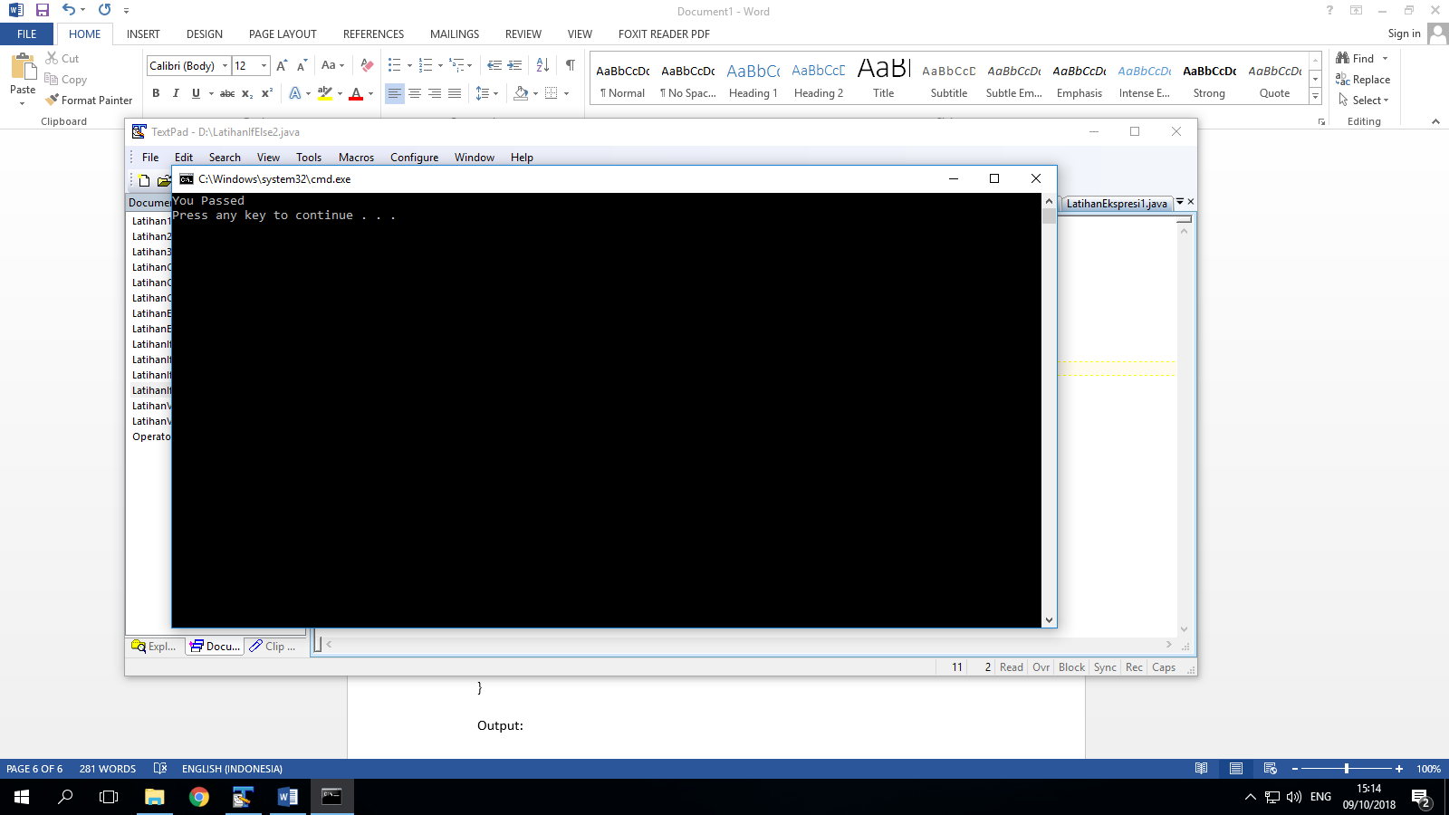

Explanation :

In this code we still use if else statement with two condition. Its look similar from previous code.

We know int grade=85

1st condition if grade is bigger than 88 the output is “you made the honor roll”

2nd condition else(that mean the other statement), if 1st statement is bigger, so it else must be smaller. So grade is smaller then 88.

And the 2nd statement fulfil this condition. That’s why the output is you passed.

PRAKTIK 5

1. Comparison in primitive variable

public class LatihanComparing1{

public static void main(String[]args){

int x= 3;

int y= 2;

int z= x+y;

boolean test= (z==x+y);

System.out.println(test);

}

}

Output:

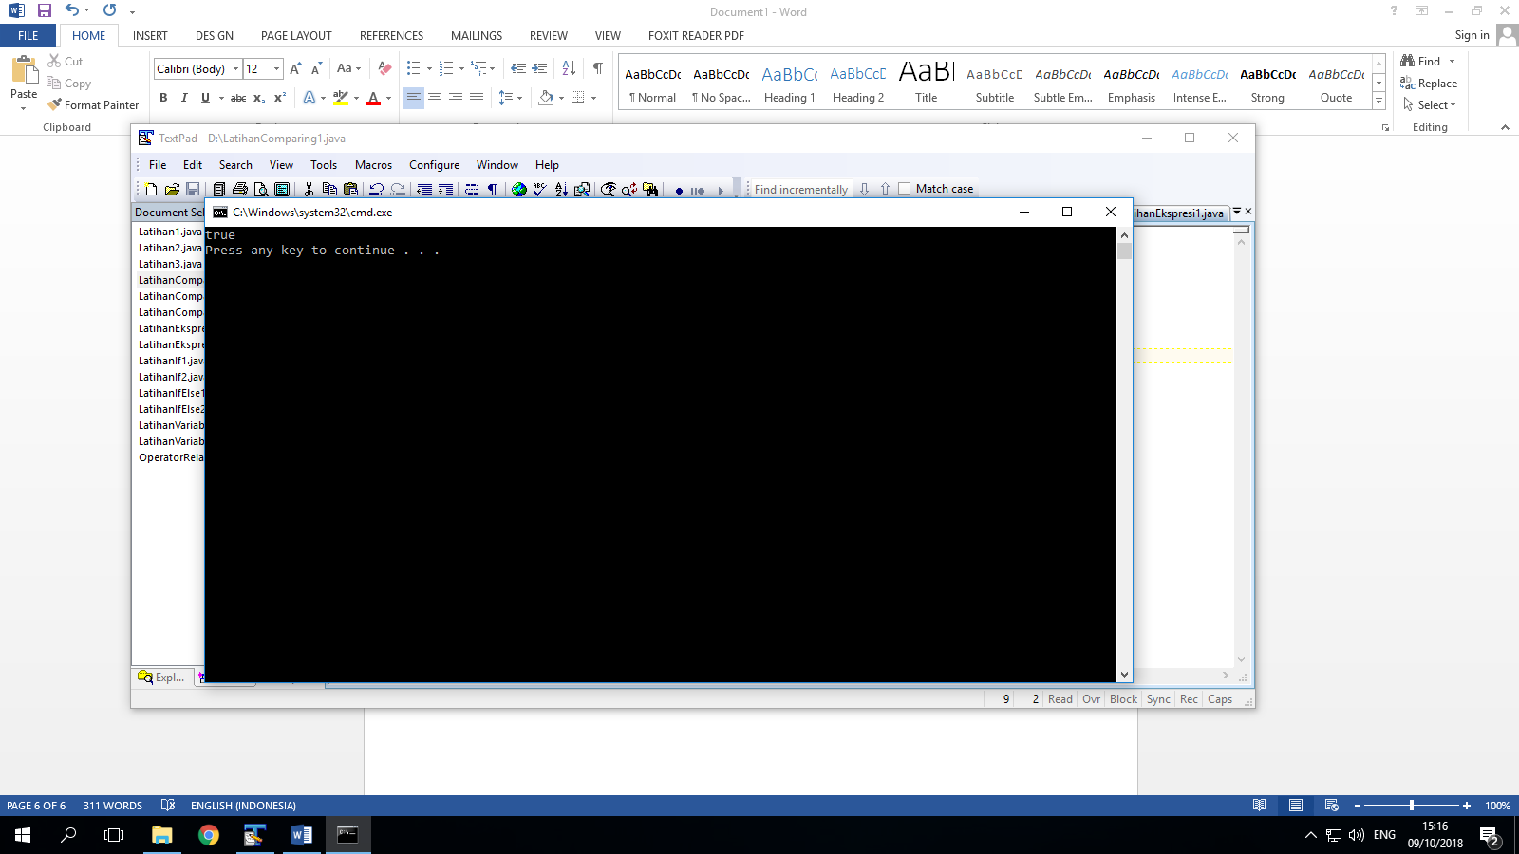

Explanation :

In this code we can see

X=3, y=2, z=x+y

The System.out.println is (test), then test = z is same with x+y.

So the output will show true because look at the “z” variable same with the test value.

1. Comparison in string

public class LatihanComparing2{

public static void main(String[]args){

String x= "Ora";

String y= "cle";

String z= x+y;

boolean test= (z== x+y);

System.out.println(test);

}

}

Output:

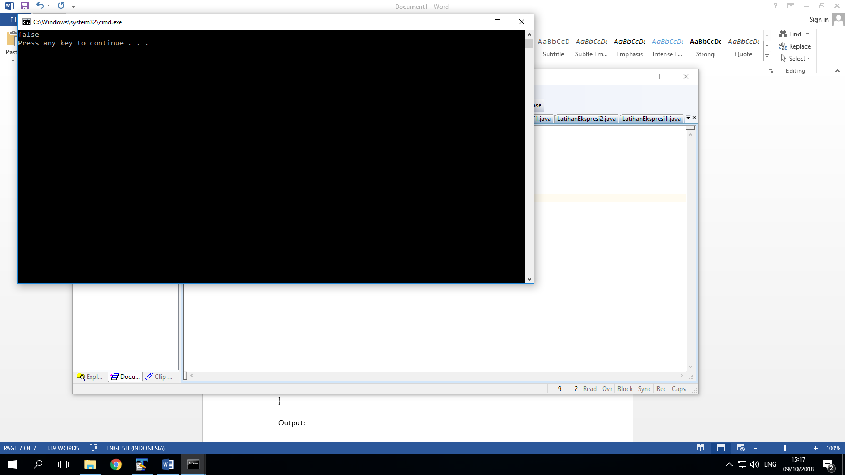

Explanation :

This code is similar with previous code, we still using a comparison.

X=Ora, y=cle, zx+y

The System.out.println is (test), then test= z is same with x+y

So the z variable is same with test value. But why the output is false?

Because it use String data type and combine with “==” operator.

So we cant use “==” for string data type.

1. Comparison in string value

public class LatihanComparing3{

public static void main(String[]args){

String x= "Ora";

String y= "cle";

String z= x+y;

boolean test= z.equals(x+y);

System.out.println(test);

}

}

Output:

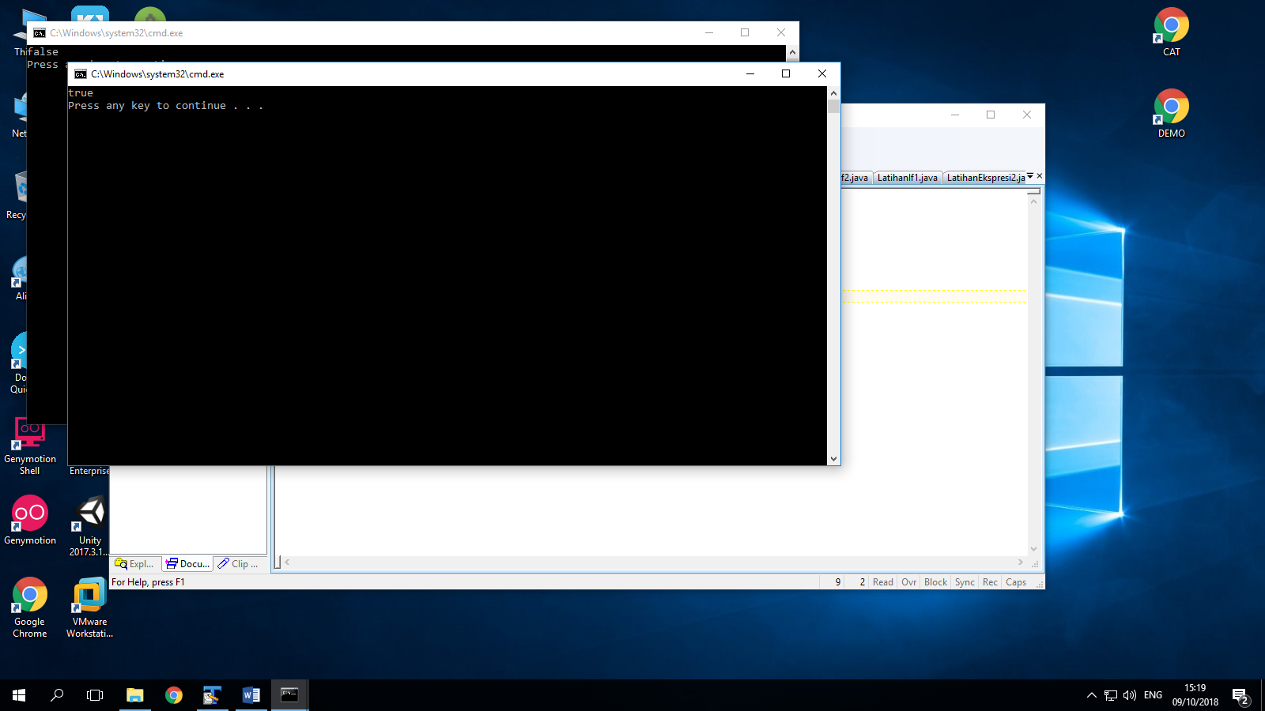

Explanation :

This code is similar from previous code. The different is, in code before use String data type combine with “==” operator and the output is false because we cant use “==” for String data type. But in this code we use String but not use “==” operator. We use equals for change the “==” operator. That’s why the answer is true because we use string in its place.

LATIHAN

1. Driving Under Age

import java.util.Scanner;

public class Latihan1{

public static void main(String[]args){

int nAge;

boolean drivingUnderAge;

Scanner input=new Scanner(System.in);

System.out.println("Enter your Age");

nAge= input.nextInt();

drivingUnderAge= false;

if(nAge<=18){

drivingUnderAge= true;

}

System.out.println(drivingUnderAge);

}

}

Output:

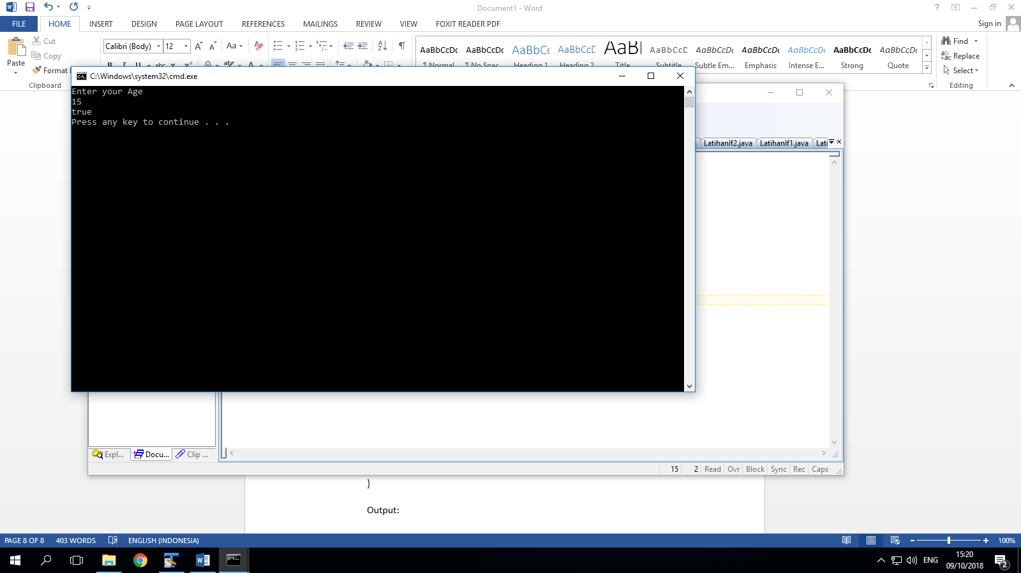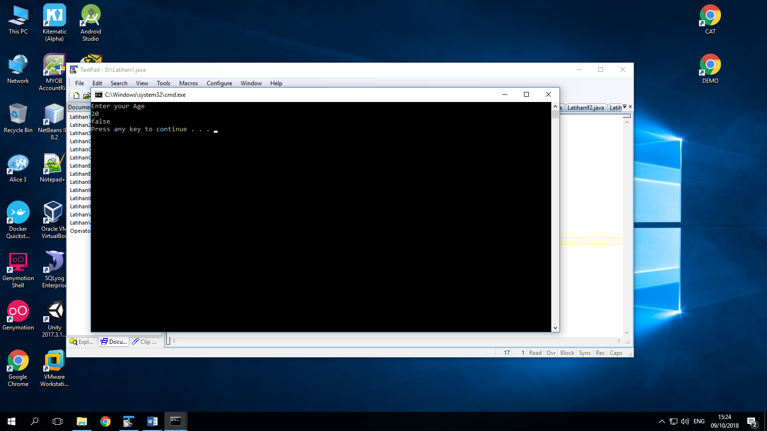

Explanation :

In this code we asked to show driving under age.

In this case we use Scanner to input from keyboard. We will asked to input our age. And we will show true or false for driving under age.

If our age under 18 the output will true, that we driving under age. But except that condition the answer is false, tha we driving under age.

1. Program to check odd or even

import java.util.Scanner;

public class Latihan2{

public static void main(String[]args){

int Nmr;

Scanner input=new Scanner(System.in);

System.out.print("Enter a number:");

Nmr= input.nextInt();

if(Nmr%2==0){

System.out.println("The Num is even " +Nmr);

}

else{

System.out.println("The Num is odd " +Nmr);

}

}

}

Output:

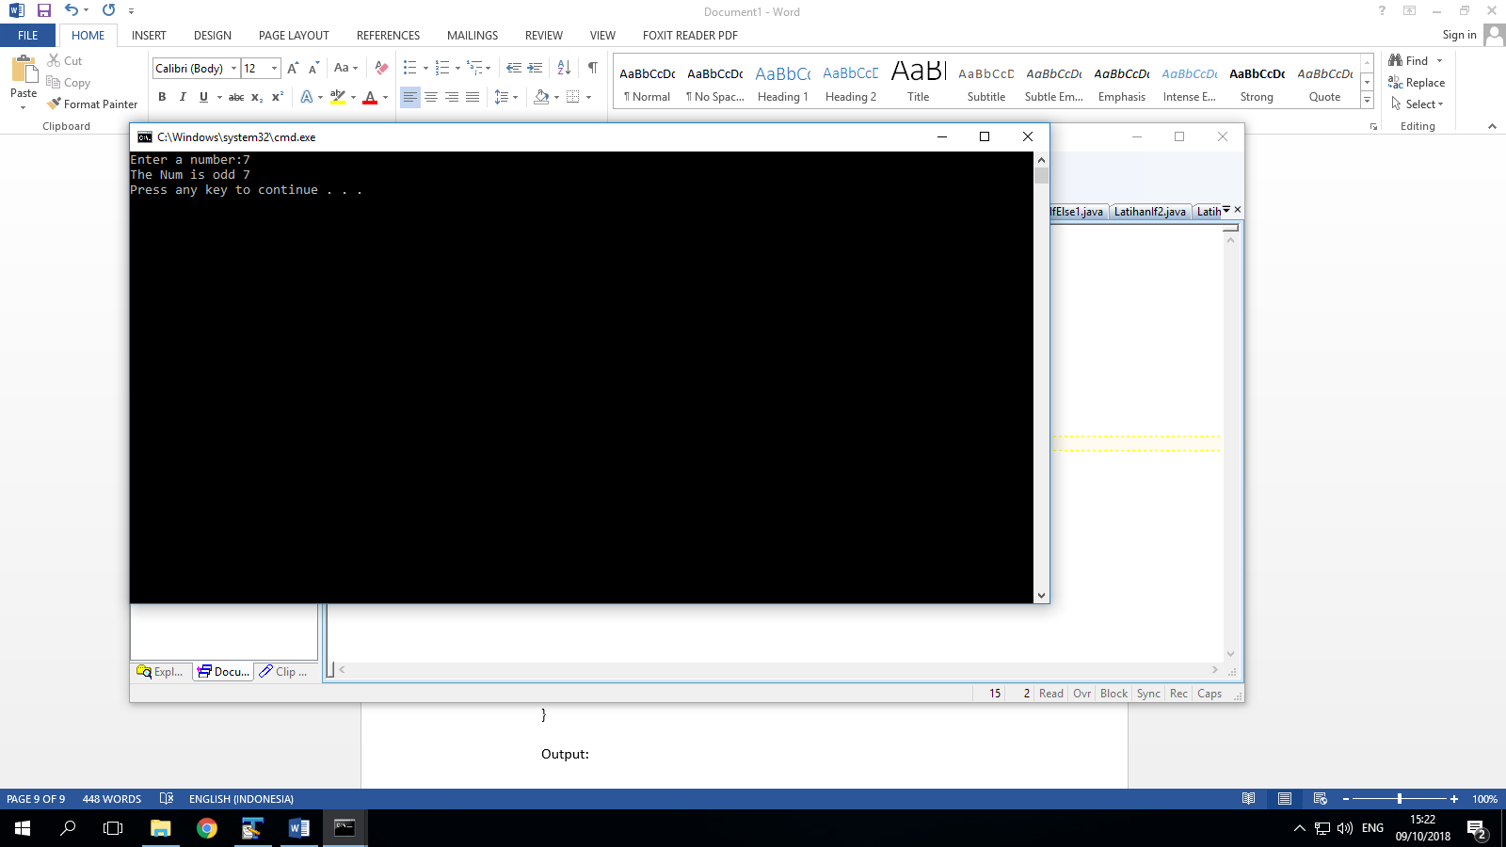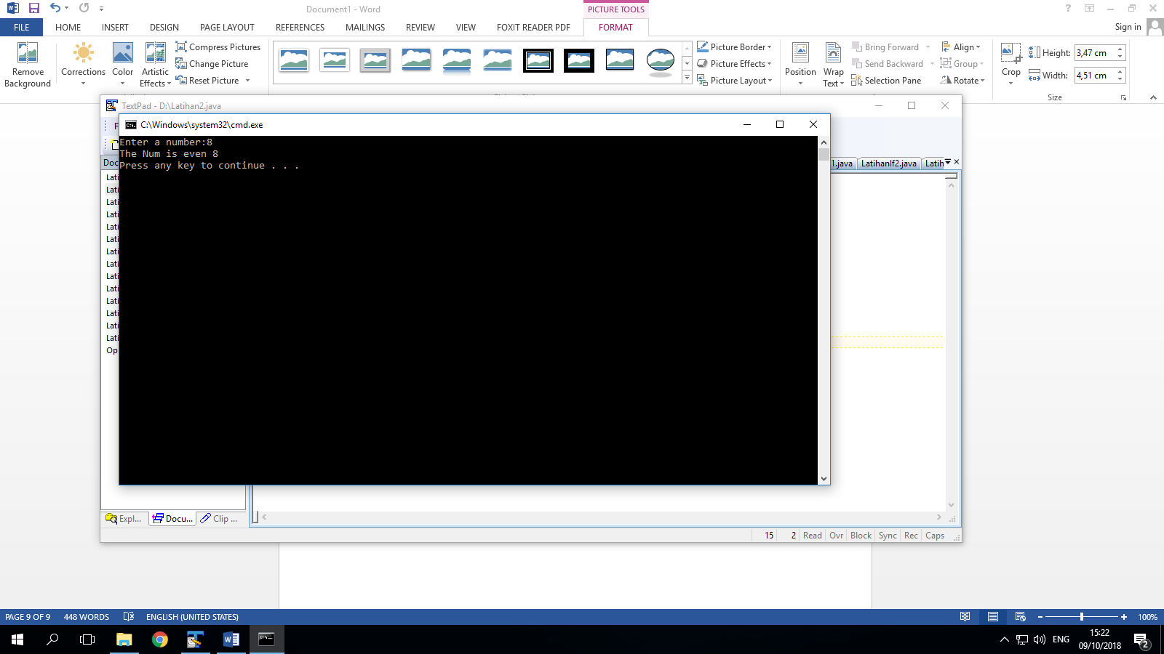

Explanation :

In this code we asked to find the odd or even number from the number that we input. So for input keyboard we use import java.util.Scanner.

The formula is, even is the number if we divide by 2 the answer is complete or there is no remain number. But if odd we divide by 2 will leave a remain number.

So even= Num%2==0, if cant fulfill this formula or statement so the answer is odd.

1. Moe is the king rock and roll

import java.util.Scanner;

public class Latihan3{

public static void main(String[]args){

String Nama;

Scanner input=new Scanner(System.in);

System.out.print("Enter your name : ");

Nama= input.next();

if(Nama.equals ("Moe")){

System.out.println("You are the king of rock and roll");

}

else{

System.out.println("You are not the king");

}

}

}

Output:

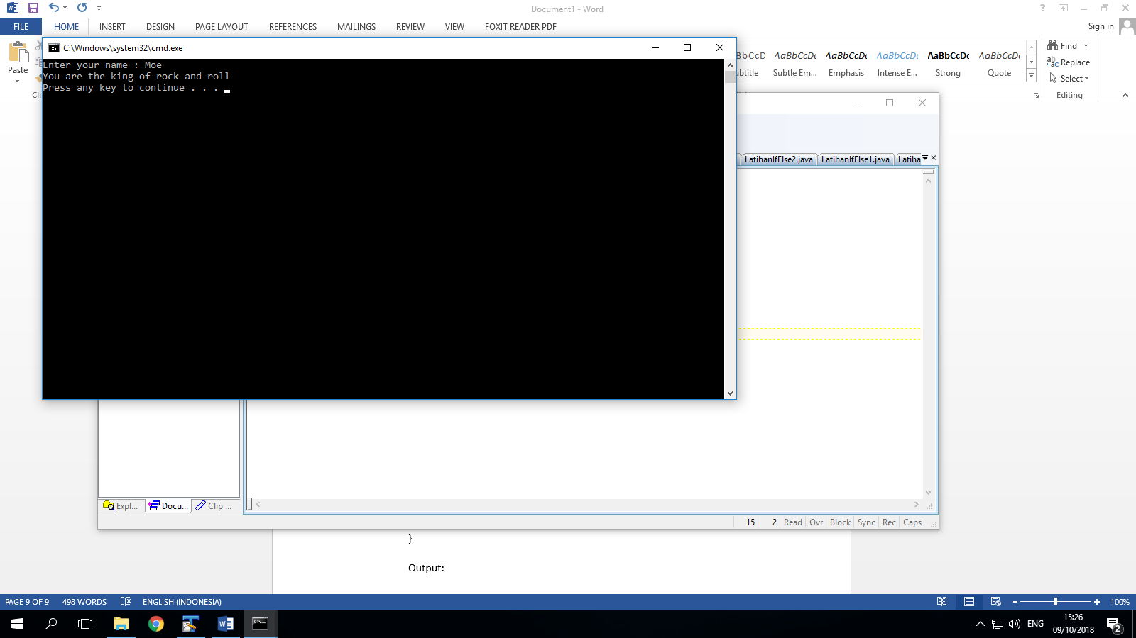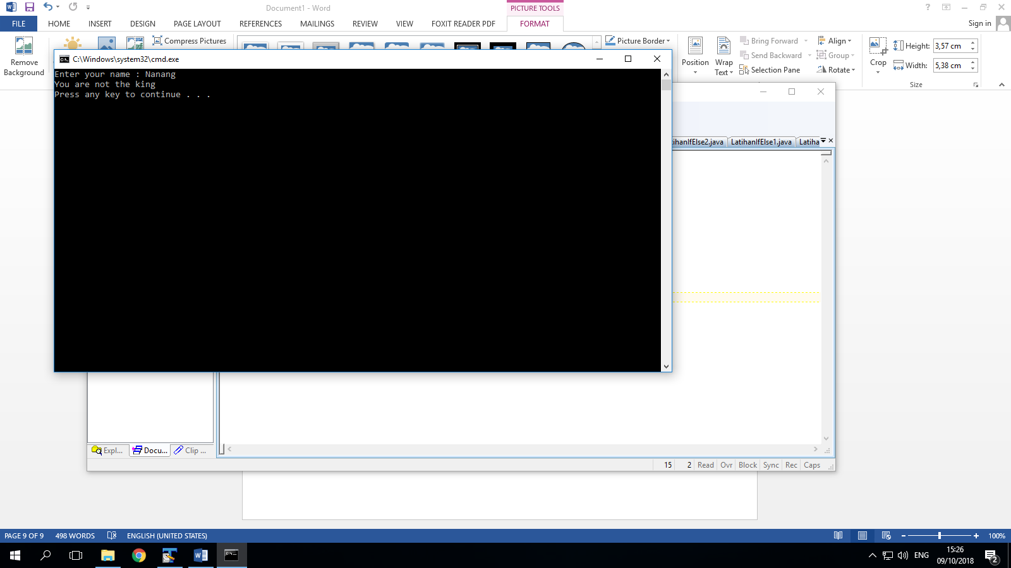

Explanation :

In this code similar with previous code.

We asked to show the “you are the king of rock and roll” output if we input “Moe” name. except Moe, the output is “you are not the king”.

Its really similar from code before. But the different is in code before we use int data type and “==” operators. And in this code we use String because we will input a name not a number and definitely we use “equals” not “==”.

And the formula is “nama.equals(Moe)”

If the name is Moe the output is “you are the king off rock and roll”

Except Moe’s name the ouput is “you are not the king”

**TUGAS**

import java.util.Scanner;

public class Tugas {

public static void main(String[]args){

int teori,praktik,praktikum,sppVar,tAkhir;

teori = 80000;

praktik = 120000;

praktikum = 150000;

System.out.println("Teori : Rp."+teori+"/sks | Praktik : Rp."+praktik+"/sks | Praktikum : Rp"+praktikum+"/sks");

Scanner input = new Scanner(System.in);

System.out.print("Masukkan jumlah sks Teori : ");

int sksTeori = input.nextInt();

System.out.print("Masukkan jumlah sks Praktik : ");

int sksPraktik = input.nextInt();

System.out.print("Masukkan jumlah sks praktikum : ");

int sksPraktikum = input.nextInt();

System.out.println("Jumlah sks teori anda :"+sksTeori+" *"+teori);

System.out.println("jumlah sks praktik anda : "+sksPraktik+" *"+praktik);

System.out.println("jumlah sks praktikum anda :"+sksPraktikum+" *"+praktikum);

sksTeori = sksTeori*teori;

sksPraktik = sksPraktik*praktik;

sksPraktikum = sksPraktikum*praktikum;

sppVar = sksTeori+sksPraktik+sksPraktikum;

System.out.println("Total Spp Variable :"+sppVar);

System.out.print("Anda mendapat diskon 25% dari total spp Vairable");

System.out.println(" = (25*sppVariable)/100");

tAkhir = (sppVar*25)/100;

System.out.println("Total akhir yang harus anda bayar adalah :"+tAkhir);

}

}

Output :

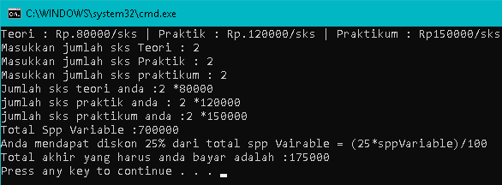

Explanation :

In this code we asked to find the final price if we took many sks determinate

Teori: 80000/sks, praktik: 120000/sks, and praktikum : 150000/sks

So in this code I input 2 sks for teori, 2 sks for praktik, and 2 sks for praktikum.

2 sks teori, so the price of teori multiple by 2 (80000*2= 160000)

2 sks praktik, so the price of teori multiple by 2 (120000*2= 240000)

2 sks praktikum, so the price of praktikum multiple by 2 (150000*2= 300000)

So total price is 700000. It same with the output.

But in this case we has 25% discount from total price (25*700000)/100=175000

So the final price is 175000.